solutions to exercises
Ex. 2–1 | a. | Assets are economic resources owned by the business entity.
 |  | 1. | Among the assets of American Airlines we might expect to find investments, accounts receivable (say, from travel agents), fuel (in storage), maintenance supplies, aircraft, and various types of equipment. The company also owns land and buildings—as, for example, its corporate headquarters.
 |  | 2. | Among the assets of a professional sports team are investments (in stocks and bonds), notes receivable (often from players), training equipment, supplies, and office furniture. (The balance sheet of a professional sports team usually does not include land or buildings, as they generally do not own the stadiums in which they play.)
Note to instructor: You may wish to expand this solution to include intangible assets, such as the team’s league franchise, and player contracts, the right to receive the future services of a given player. (Player contracts only appear as an asset if they have a cost—that is, if they were purchased from other teams. Advance payments to players usually are shown as prepaid expenses.) We address intangible assets in Chapter 9, but the concept is consistent with the discussion of assets in Chapter 2.
 | b. | Liabilities are existing debts and other obligations of the entity.
 |  | 1. | Among the liabilities of American Airlines, we might expect to find accounts payable, notes payable (or mortgages or bonds payable) stemming from purchases of aircraft, salaries payable, interest payable, rent payable (for space in airports), and income taxes payable.
 |  | 2. | The balance sheet of a professional sports team might include accounts payable, rent payable (for the stadium), salaries payable, interest payable, and income taxes payable.
Note to instructor: In a classroom discussion, you might want to point out that both an airline and a professional sports team may have liabilities for unearned revenue. The airline sells many tickets in advance, thus incurring an obligation to render services (flights) or to refund the customers’ money. A sports team has a similar obligation with respect to advance sales of season tickets. We discuss unearned revenue in Chapter 4, but the concept can be introduced earlier at the instructor’s discretion.

Ex. 2–2 | DIXIE TRANSPORTATION SERVICE  Balance Sheet  February 28, 2005
 | Assets |  |  | Liabilities & Owners’ Equity
 | Cash | $ 69,000 |  | Liabilities:
 | Accounts receivable | 70,000 |  |  | Notes payable |  | $ 288,000
 | Supplies | 14,000 |  |  | Accounts payable |  | 26,000
 | Land | 70,000 |  |  |  | Total liabilities | $ 314,000
 | Building | 80,000 |  | Owners’ equity:
 | Automobiles | 165,000 |  | Capital stock |  |  | 92,000
 | Total | $ 468,000 |  |  | Retained earnings |  | 62,000
 |  |  |  | Total |  |  | $ 468,000

Ex. 2–3 | MERCER COMPANY  Balance Sheet  December 31, 2005
 | Assets |  |  | Liabilities & Owners’ Equity
 | Cash | $ 36,300 |  | Liabilities:
 | Accounts receivable | 56,700 |  |  | Notes payable |  | $207,000
 | Land | 90,000 |  |  | Accounts payable |  | 43,800
 | Building | 210,000 |  |  |  | Total liabilities | $250,800
 | Office equipment | 12,400 |  | Owners’ equity:
 |  |  |  | Capital stock |  |  | 75,000
 |  |  |  |  | Retained earnings |  | 79,600
 | Total | $405,400 |  | Total |  |  | $405,400
 | The amount of retained earnings is calculated as the difference between total assets and liabilities plus capital stock: $405,400 – ($250,800 + $75,000) = $79,600

Ex. 2–4 | a. | The supplies should be presented at $1,700 in World-Wide’s balance sheet. Presenting the supplies at their estimated liquidation value violates the assumption that World-Wide is a going concern, and will use these supplies in business operations, rather than sell them on the open market. The $500 amount also violates the objectivity principle, as it is largely a matter of personal opinion, and also the cost principle.
 | b. | The presentation of the two land parcels at a combined value of $320,000 conforms to generally accepted accounting principles. This treatment illustrates both the cost principle and the stable-dollar assumption.
 | c. | The presentation of the computer system at $14,000 in the December 31 balance sheet conforms to generally accepted accounting principles, as this is the cost of the system, and at the balance sheet date, it was an asset owned by the company. The retail value of $20,000 is not presented in the balance sheet, as this amount is not the cost incurred by the entity, nor is it an objective measurement.
 |  | However, the company’s failure to disclose the loss of the equipment subsequent to the balance sheet date may violate the principle of adequate disclosure. To properly interpret the company’s balance sheet, users may need to be aware that this asset no longer exists. Several issues must be considered in deciding whether or not disclosure of the burglary loss is necessary. For example, was the asset insured? And is a $14,000 asset significant (material) in relation to the assets and operations of this business? Is this amount large enough that it might impact investors’ and creditors’ decisions regarding the company?

Ex. 2–5 | a. | $236,000: Assets $578,000 − liabilities $342,000 = owners’ equity $236,000
 | b. | $1,132,500: Liabilities $562,500 + owners’ equity $570,000 = assets $1,132,500
 | c. | $120,300: Assets $307,500 − owners’ equity $187,200 = liabilities $120,300

Ex. 2–6 | Transaction |  | Assets | = | Liabilities | + | Owners’ Equity
 | a |  | I |  | I |  | NE
 | b |  | NE* |  | NE |  | NE
 | c |  | D |  | D |  | NE
 | d |  | D |  | D |  | NE
 | e |  | I |  | NE |  | I
 | f |  | I |  | I |  | NE
 | g |  | I |  | NE |  | I
 | h |  | NE* |  | NE |  | NE
 | i |  | NE* |  | NE |  | NE
 | *Could be I/D offsetting

Ex. 2–7 | Note to instructor: These are examples, but many others exist.
 | a. | The purchase of office equipment (or any other asset) on credit will cause an increase in the asset (office equipment) and an increase in a liability.
 | b. | The cash payment of an account payable or note payable will cause a decrease in the asset cash and a decrease in the liability paid.
 | c. | The collection of an account receivable will cause an increase in one asset (cash) and a decrease in another asset (accounts receivable). Other examples include the purchase of land for cash, and the sale of land for cash or on credit.
 | d. | The investment of cash in the business by the owners will cause an increase in an asset (cash) and an increase in the owners’ equity.
 | e. | The purchase of an automobile (or other asset) paying part of the cost in cash and promising to pay the remainder at a later time would cause an increase in one asset (automobile), a decrease in another asset (cash), and an increase in a liability by the amount of the unpaid portion.

Ex. 2–8 | a. | (1) | Owner’s equity:
 |  |  |  | Johanna Small, capital |  | $390,000
 |  |  | *$850,000 in assets − $460,000 in liabilities
 |  | (2) | Partners’ equity:
 |  |  |  | Johanna Small, capital |  | $240,000
 |  |  |  | Mikki Yato, capital |  | 150,000
 |  |  |  |  | Total partners’ equity | $390,000
 |  |  | *Yato’s capital = $390,000 − Small’s capital, $240,000
 |  | (3) | Stockholders’ equity:
 |  |  |  | Capital stock |  | $250,000
 |  |  |  | Retained earnings |  | 140,000
 |  |  |  |  | Total stockholders’ equity | $390,000
 |  |  | *Capital stock = 25 × $10,000. Retained earnings = $390,000 − capital stock.

 | b. | Yes; the form of Fellingham’s organization is relevant to a lender. If the company is not incorporated, the owner or owners are personally liable for the debts of the business organization. Thus, if the business is organized as a sole proprietorship, it is actually Small’s personal debt-paying ability that determines the collectibility of loans to the business. If the business is a partnership, all of the partners are personally liable for the company’s debts.
 |  | If Fellingham Software is organized as a corporation, however, a lender may look only to the corporate entity for payment.
Note to instructor: You may wish to point out that some lenders would not make sizable loans to a small corporation unless one or more of the stockholders personally guaranteed the loan. This is accomplished by having the stockholder(s) cosign the note.

Ex. 2–9 | a. | Cash is the most liquid of all assets. In fact, companies must use cash in paying most bills. Therefore, cash contributes more to a company’s liquidity than any other asset does.
 | b. | Accounts payable is a liability that requires payment, usually in the near future. Thus, existing accounts payable detract from liquidity.
 | c. | Accounts receivable are assets that will shortly convert into cash. Therefore, they contribute toward the company’s liquidity.
 | d. | The capital stock account is the owners’ equity of the business. It represents amounts originally invested in the business by the owner, but says nothing about the form in which the company now holds these resources—nor even whether the resources are still on hand. Thus, the capital stock account has no direct effect upon liquidity. On the other hand, the amount of the owners’ equity, related to the amount of the liabilities is an important factor in evaluating liquidity.

Ex. 2–10 | a. | The situations encountered in the practice of accounting and auditing are too complex and too varied for all specific answers to be set forth in a body of official rules. Therefore, individual accountants must resolve many situations, based upon their general knowledge of accounting, their experience, and their ethical standards—in short, their professional judgment.
 | b. | Accountants must rely upon their professional judgment in such matters as determining (three required) (1) how to record an unusual transaction that is not discussed in accounting literature, (2) whether or not a specific situation requires disclosure, (3) what information will be most useful to specific decision makers, (4) how an accounting system should be designed to operate most efficiently, (5) the audit procedures necessary in a given situation, (6) what constitutes a fair presentation, (7) whether specific actions are ethical and are in keeping with the accountants’ responsibilities to serve the public’s interests.

Ex. 2–11 | GARDIAL Company  Statement of Cash Flows  For the Month Ended October 31, 2005
 | Cash flows from operating activities:
 |  | Cash received from revenues | $ 10,000
 |  | Cash paid for expenses | (7,200)
 |  | Net cash provided by operating activities |  | $2,800
 | Cash flows from investing activities:
 |  | Cash paid for equipment |  |  | (2,500)
 | Cash flows from financing activities:
 |  | Cash received from sale of capital stock | $ 6,000
 |  | Cash used to repay bank loans | (2,000)
 |  | Net cash provided by financing activities |  |  | 4,000
 | Increase in cash |  |  |  | $ 4,300
 | Cash balance, October 1, 2005 |  |  |  | 7,450
 | Cash balance, October 31, 2005 |  |  |  | $11,750

Ex. 2–12 | HERNANDEZ, Inc.  Income Statement  For the Month Ended March 31, 2005
 | Revenues | $9,500
 | Expenses | 5,465
 | Net income | $4,035
 | The cash received from bank loans is a positive cash flow—financing activity—in the statement of cash flows, but is not included in the income statement. Dividends paid to stockholders are a negative cash flow—financing activity—in the statement of cash flows, but are not included in the income statement.

Ex. 2–13 | YARNELL Company  Income Statement  For the Month Ended August 31, 2005
 | Service revenues | $15,000
 | Expenses | 7,500
 | Net income | $ 7,500
The following four items represent cash flows, but are not revenues or expenses that should be included in the income statement:
- Investment by stockholders
- Loan from bank
- Payments to long-term creditors
- Purchase of land

Ex. 2–14 | YARNELL Company  Statement of Cash Flows  For the Month Ended August 31, 2005
 | Cash flows from operating activities:
 |  | Cash received from revenues | $ 15,000
 |  | Cash paid for expenses | (7,500)
 |  | Net cash provided by operating activities |  | $ 7,500
 | Cash flows from investing activities:
 |  | Cash paid for purchase of land |  | (16,000)
 | Cash flows from financing activities:
 |  | Cash received from bank loan | $ 15,000
 |  | Cash received from investment by stockholders | 5,000
 |  | Cash paid to long-term creditors | (12,000)
 |  | Net cash provided by financing activities |  | 8,000
 | Decrease in cash |  |  | $ (500)
 | Cash balance, August 1, 2005 |  |  | 7,200
 | Cash balance, August 31, 2005 |  |  | $ 6,700

Ex. 2–15 | John Franklin, owner’s equity:
 |  | Balance, January 1, 2005 |  | $50,000
 |  | Add: | Investment during 2005 | 10,000
 |  |  | Net income for 2005 | 25,000
 |  | Balance, December 31, 2005 |  | $85,000
 | The end-of-year balance of owner’s equity in the balance sheet is $85,000. This amount articulates with the amount of net income in the income statement because net income is added to the amount of beginning owner’s equity, plus additional investment, to determine the ending balance that appears in the December 31, balance sheet. The accounting equation stays in balance because the amount of net income is reflected in changes in the balances of various assets and liabilities that are also presented in the balance sheet.

Ex. 2–16 | Note to instructor: Many examples of steps to improve the financial statements could be cited. The ones listed below are those that the authors believe are most likely to be identified by students.
 | Steps to Window Dress |  | Impact on Financial Statements*
 | Delay cash payment of expenses at year-end (assume expense already incurred) |  | BS—Higher cash balance  IS—No impact  SCF—Higher cash from operating activities
 | Accelerate payment of liabilities at  year-end |  | BS—Reduced cash and liability balances  IS—No impact  SCF—Lower cash balance
 | Delay purchase of equipment (or other noncurrent asset) |  | BS—Higher cash balance  IS—No impact  SCF—Lower cash used in investing activities
 | Year-end investment by owner |  | BS—Higher cash and owners’ equity balances  IS—No impact  SCF—Higher cash flow from financing activities
 | Year-end borrowing |  | BS—Higher cash and liability balances  IS—No impact  SCF—Higher cash flow from financing activities
 | Acceleration of credit sales at year-end |  | BS—Higher receivables and owners’ equity balances  IS—Higher sales and net income  SCF—No impact (assuming receivables not  collected)
 | *BS = Balance sheet; IS = Income statement; SCF = Statement of cash flows

Ex. 2–17 | a. | The company has a net income (earnings) of $66,388 thousand for the year ended December 31, 2002.
 | b. | Cash balances at the beginning and end of the year were:
 |  | End | $105,507 thousand
 |  | Beginning | 106,532 thousand
 |  | Decrease | $ 1,025 thousand
 |  | Major causes of the decrease in the amount of cash are the purchases of investments and capital expenditures, all of which are investing activities. Financing activities also caused cash to decrease, primarily due to the repurchase and retirement of capital stock.
 | c. | The largest asset is machinery and equipment ($196,706 thousand before depreciation). The largest liability is accrued liabilities (expenses) ($35,825 thousand).

Ex. 2–18 | Net income stated as a percentage of revenue for each year is as follows:
2000: $10,535/$33,726 = 31%
2001: $1,291/$26,539 = 5%
2002: $3,117/$26,764 = 12%

The trend is basically negative, although 2002 is higher than 2001. Both sales and net income were the highest in 2000 of the three years 2000-2002. Between 2000 and 2001, both sales and net income dropped dramatically. Net income as a percentage of sales dropped from a high of 31% in 2000 to a low of 5% in 2001. 2002 can be described as a “rebounding year” in which net income increased significantly, though not to the 2000 level, and sales increased slightly. As a percentage of sales, net income in 2002 rose to 12%, a clear improvement over 2001 but not nearly as positive as in 2000.
solutions to problems
15 Minutes, Easy | Problem 2–1  Smokey mountain lodge
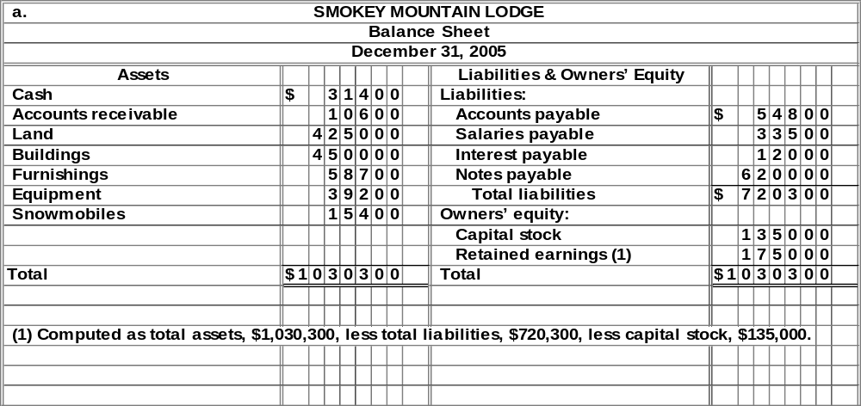
b. | The balance sheet indicates that Smokey Mountain Lodge is in a weak financial position. The highly liquid assets—cash and receivables—total only $42,000, but the company has $100,300 of debts due in the near future (accounts payable, salaries payable, and interest payable).
Note to instructor: Students were asked to base their answers to part b on the balance sheet alone. Students may correctly point out that a balance sheet does not indicate the rate at which cash flows into a business. Perhaps the company can generate enough cash from daily operations to pay its debts. A recent statement of cash flows would be useful in making a more complete analysis of the company’s financial position.

15 Minutes, Easy |  | Problem 2–2  AJAX Moving Company
Description of transactions:
a. | Purchased equipment for cash at a cost of $3,200.
b. | Received $900 cash from collection of accounts receivable.
c. | Purchased equipment at a cost of $13,500; paid $3,500 cash as down payment and incurred a liability (account payable) for the remaining $10,000.
d. | Paid $14,500 of accounts payable.
e. | $15,000 cash was received from the sale of capital stock.
f. | Purchased equipment on account for $7,500.

15 Minutes, Medium | Problem 2–3  GOLDSTAR communications
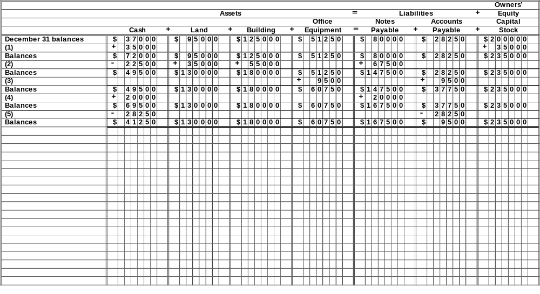

15 Minutes, Medium | Problem 2–4  rANKIN truck rental
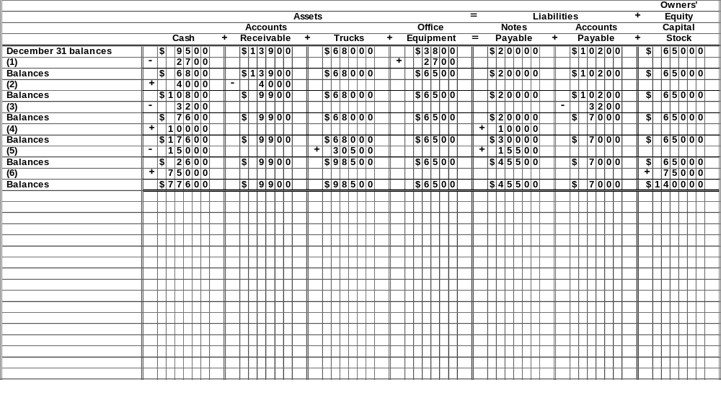

20 Minutes, Medium | Problem 2–5  Here come the clowns!
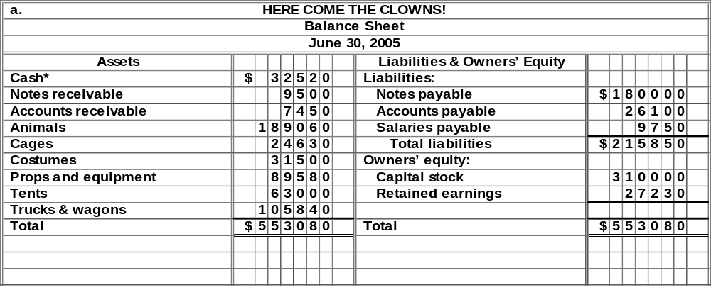
* | Total liabilities and owners’ equity, $553,080, minus total of all other assets, $520,560 ($9,500 + $7,450 + $189,060 + $24,630 + $31,500 + $89,580 + $63,000 + $105,840).
b. | The loss of an asset, Tents, from a fire would require a revised balance sheet that reflects a decrease in total assets. When total assets are decreased, the other balance sheet total (that is, the total of liabilities and owners’ equity) must also decrease. Since there is no change in liabilities as a result of the destruction of an asset, the decrease on the right-hand side of the balance sheet must be in owners’ equity—specifically, the retained earnings account. The amount of the decrease in the assets Tents, in Retained earnings, and in both balance sheet totals, is $14,300.

20 Minutes, Medium | Problem 2–6  wILSON farms, iNC.
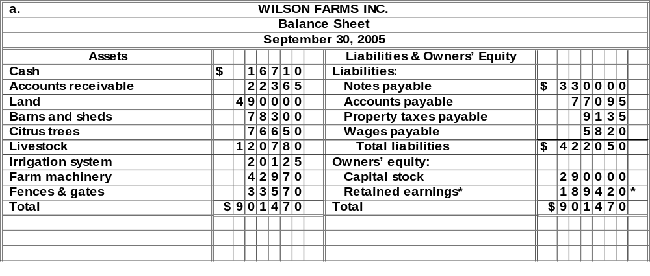
*Total assets, $901,470, minus total liabilities, $422,050, less capital stock, $290,000.
b. | The loss of an asset, Barns and Sheds, from a tornado would cause a decrease in total assets. When total assets are decreased, the balance sheet total of liabilities and owners’ equity must also decrease. Since there is no change in liabilities as a result of the destruction of an asset, the decrease on the right-hand side of the balance sheet must be in the retained earnings account. The amount of the decrease in Barns and Sheds, in the owners’ equity, and in both balance sheet totals, is $13,700.

35 Minutes, Medium | Problem 2–7  The OVEN bakery
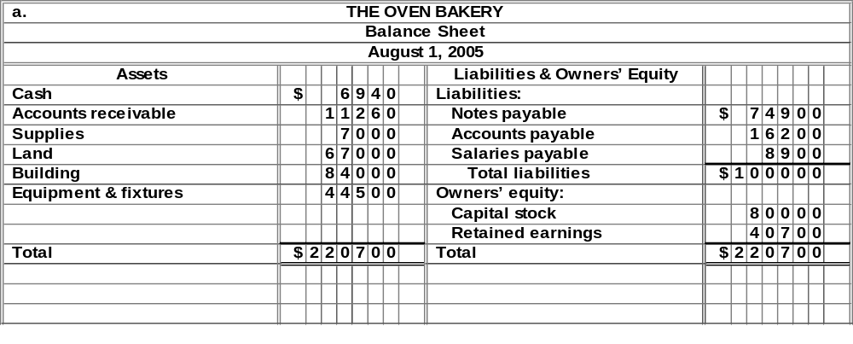

Retained earnings ($40,700) = Total assets ($220,700), less total liabilities ($100,000) and capital stock ($80,000).

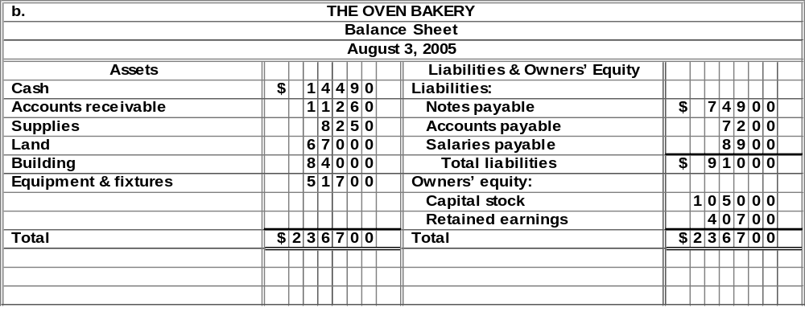
Problem 2–7
The OVEN bakery (concluded)
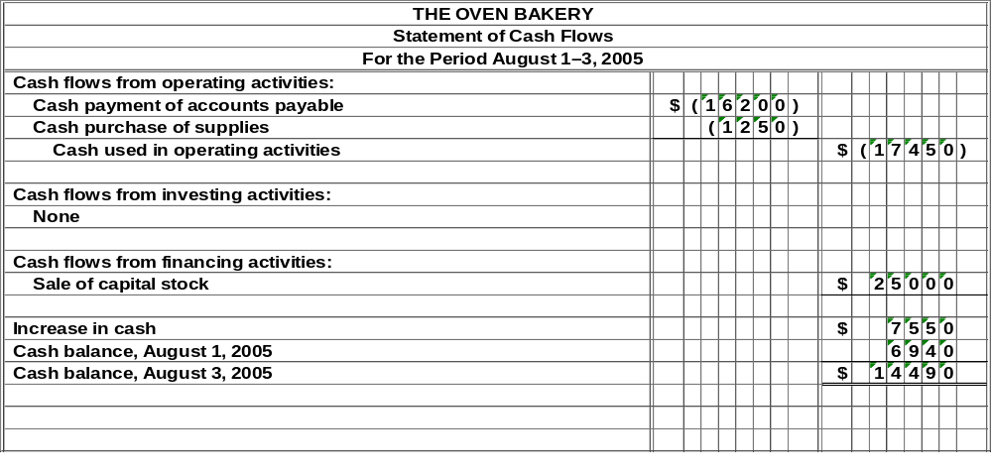
c. | The Oven Bakery is in a stronger financial position on August 3 than it was on August 1.
 | On August 1, the highly liquid assets (cash and accounts receivable) total only $18,200, but the company has $25,100 in debts due in the near future (accounts payable plus salaries payable).
 | On August 3, after additional infusion of cash from the sale of stock, the liquid assets total $25,750, and debts due in the near future amount to $16,100.
Note to instructor: The analysis of financial position strength in part c is based solely upon the balance sheets at August 1 and August 3. Hopefully, students will raise the issue regarding necessity of information about operations, rate at which cash flows into the business, etc. In this problem, the improvement in financial position results solely from the sale of capital stock.

40 Minutes, Strong | Problem 2–8  the sWEET SODA shop
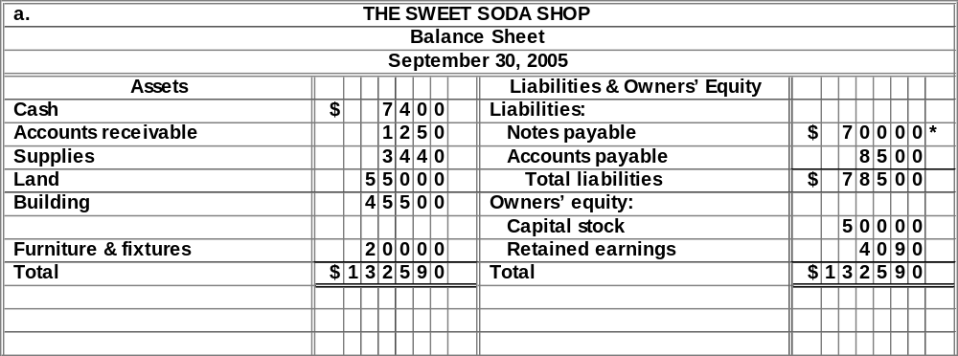
*Total assets, $132,590, less owners’ equity, $54,090, less accounts payable, $8,500, equals notes payable.
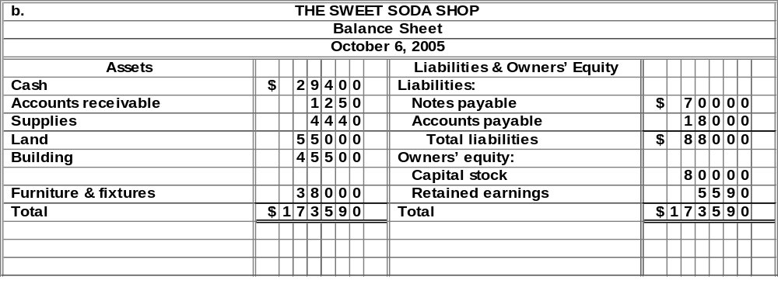

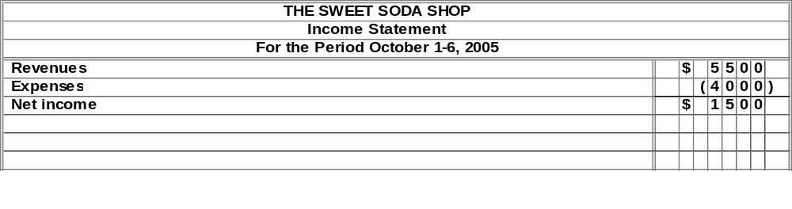

Problem 2–8
the SWEET SODA shop (concluded)
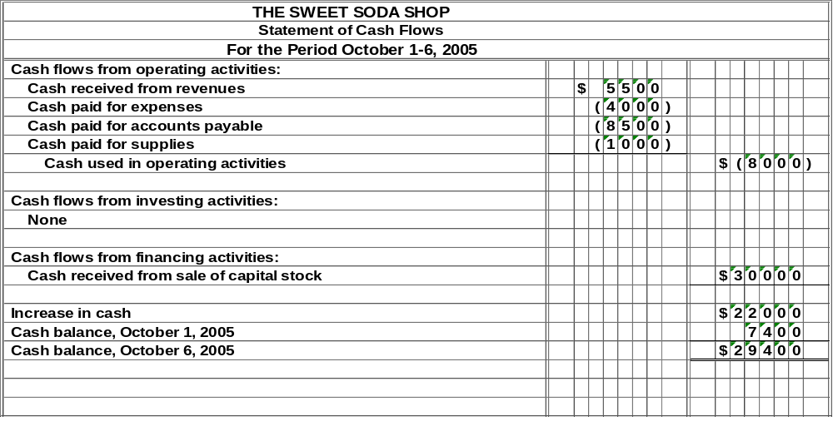
c. | The Sweet Soda Shop is in a stronger financial position on October 6 than on September 30. On September 30, the company had highly liquid assets (cash and accounts receivable) of $8,650, which barely exceeded the $8,500 in liabilities (accounts payable) due in the near future. On October 6, after the additional investment of cash by stockholders, the company’s cash alone exceeded its short-term obligations.

35 Minutes, Strong | Problem 2–9  Berkeley playhouse
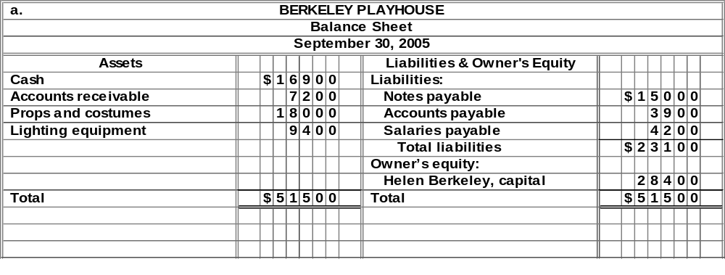
b. | (1) | The cash in Berkeley’s personal savings account is not an asset of the business entity Berkeley Playhouse. Therefore, it should not appear in the balance sheet of the business. The money on deposit in the business bank account ($15,000) and in the company safe ($1,900) constitute cash owned by the business. It is not necessary to state separately in the balance sheet amounts of cash at different locations; thus, the cash owned by the business at September 30 totals $16,900.
 | (2) | Only the amount receivable from Artistic Tours ($7,200) should be included in the company’s accounts receivable as of September 30. The amounts expected from future tickets sales do not relate to completed transactions and are not yet assets of the business.
 | (3) | The props and costumes should be shown in the balance sheet at their cost, $18,000, not at just the portion of the cost that was paid in cash. The $15,000 note payable is a debt of the business arising from a completed purchase transaction. Therefore, it should be included among the company’s liabilities. The date at which this liability must be paid is not relevant.
 | (4) | The theater building is not owned by Berkeley Playhouse. Therefore, it is not an asset of this business entity and should not appear in the balance sheet.
 | (5) | The lighting equipment is an asset of the business and should be valued in the balance sheet at its cost, $9,400.
 | (6) | As the automobile is not used in the business, it appears to be Berkeley’s personal asset rather than an asset of the business entity. Therefore, it should not be included in the balance sheet of the business. (Note: The advertised sales price of a similar automobile would not be an appropriate valuation figure even if the automobile were to be included.)
 | (7) | The accounts payable should be limited to the debts of the business, $3,900, and should not include Berkeley’s personal liabilities.

Problem 2–9
BERKELEY playhouse (concluded)
 | (8) | The amount owed to stagehands for work done through September 30 is the result of completed transactions and should be included among the liabilities of the business. Even if agreement has been reached with Mario Dane for him to perform in a future play, he has not yet performed and, therefore, is not yet owed any money. Thus, this $25,000 is not yet a liability of the business.
 | (9) | Owner’s equity is not valued at either the original amount invested or at the estimated market value of the business. In fact, owner’s equity cannot be valued independently of the values assigned to assets and liabilities. Rather, it is a residual figure—the excess of total assets over total liabilities. (If liabilities exceed assets, owner’s equity would be a negative amount.) Thus, the amount of Berkeley’s capital should be determined by subtracting the corrected figure for total liabilities ($23,100) from the corrected amount of total assets ($51,500). This indicates owner’s equity of $28,400.

30 Minutes, Strong | Problem 2–10  big screen scripts
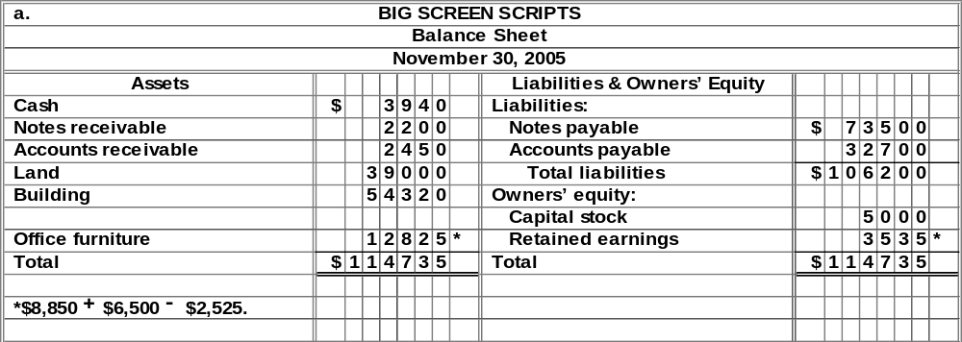* Total assets ($114,735), Less (Total Liabilities, $106,200, + Capital Stock, $5,000)

b. | (1) | The cash in Pippin’s personal savings account is not an asset of the business entity Big Screen Scripts and should not appear in the balance sheet of the business. The money on deposit in the business bank account ($3,400) and in the company safe ($540) constitute cash owned by the business. Thus, the cash owned by the business at November 30 totals $3,940.
 | (2) | The years-old IOU does not qualify as a business asset for two reasons. First, it does not belong to the business entity. Second, it appears to be uncollectible. A receivable that cannot be collected is not viewed as an asset, as it represents no future economic benefit.
 | (3) | The total amount to be included in “Office furniture” for the rug is $9,400, the total cost, regardless of whether this amount was paid in cash. Consequently, “Office furniture” should be increased by $6,500. The $6,500 liability arising from the purchase of the rug came into existence prior to the balance sheet date and must be added to the “Notes payable” amount.
 | (4) | The computer is no longer owned by Big Screen Scripts and therefore cannot be included in the assets. To do so would cause an overstatement of both assets and owners’ equity. The “Office furniture” amount must be reduced by $2,525.
 | (5) | The $22,400 described as “Other assets” is not an asset, because there is no valid legal claim or any reasonable expectation of recovering the income taxes paid. Also, the payment of federal income taxes by Pippin was not a business transaction by Big Screen Scripts. If a refund were obtained from the government, it would come to Pippin personally, not to the business entity.
 | (6) | The proper valuation for the land is its historical cost of $39,000, the amount established by the transaction in which the land was purchased. Although the land may have a current fair value in excess of its cost, the offer by the friend to buy the land if Pippin would move the building appears to be mere conversation rather than solid, verifiable evidence of the fair value of the land. The “cost principle,” although less than perfect, produces far more reliable financial statements than would result if owners could “pull figures out of the air” in recording asset values.
 | (7) | The accounts payable should be limited to the debts of the business, $32,700, and should not include Pippin’s personal liabilities.

